2026 Lolo IHC Temporary (1039) Recruitment Information
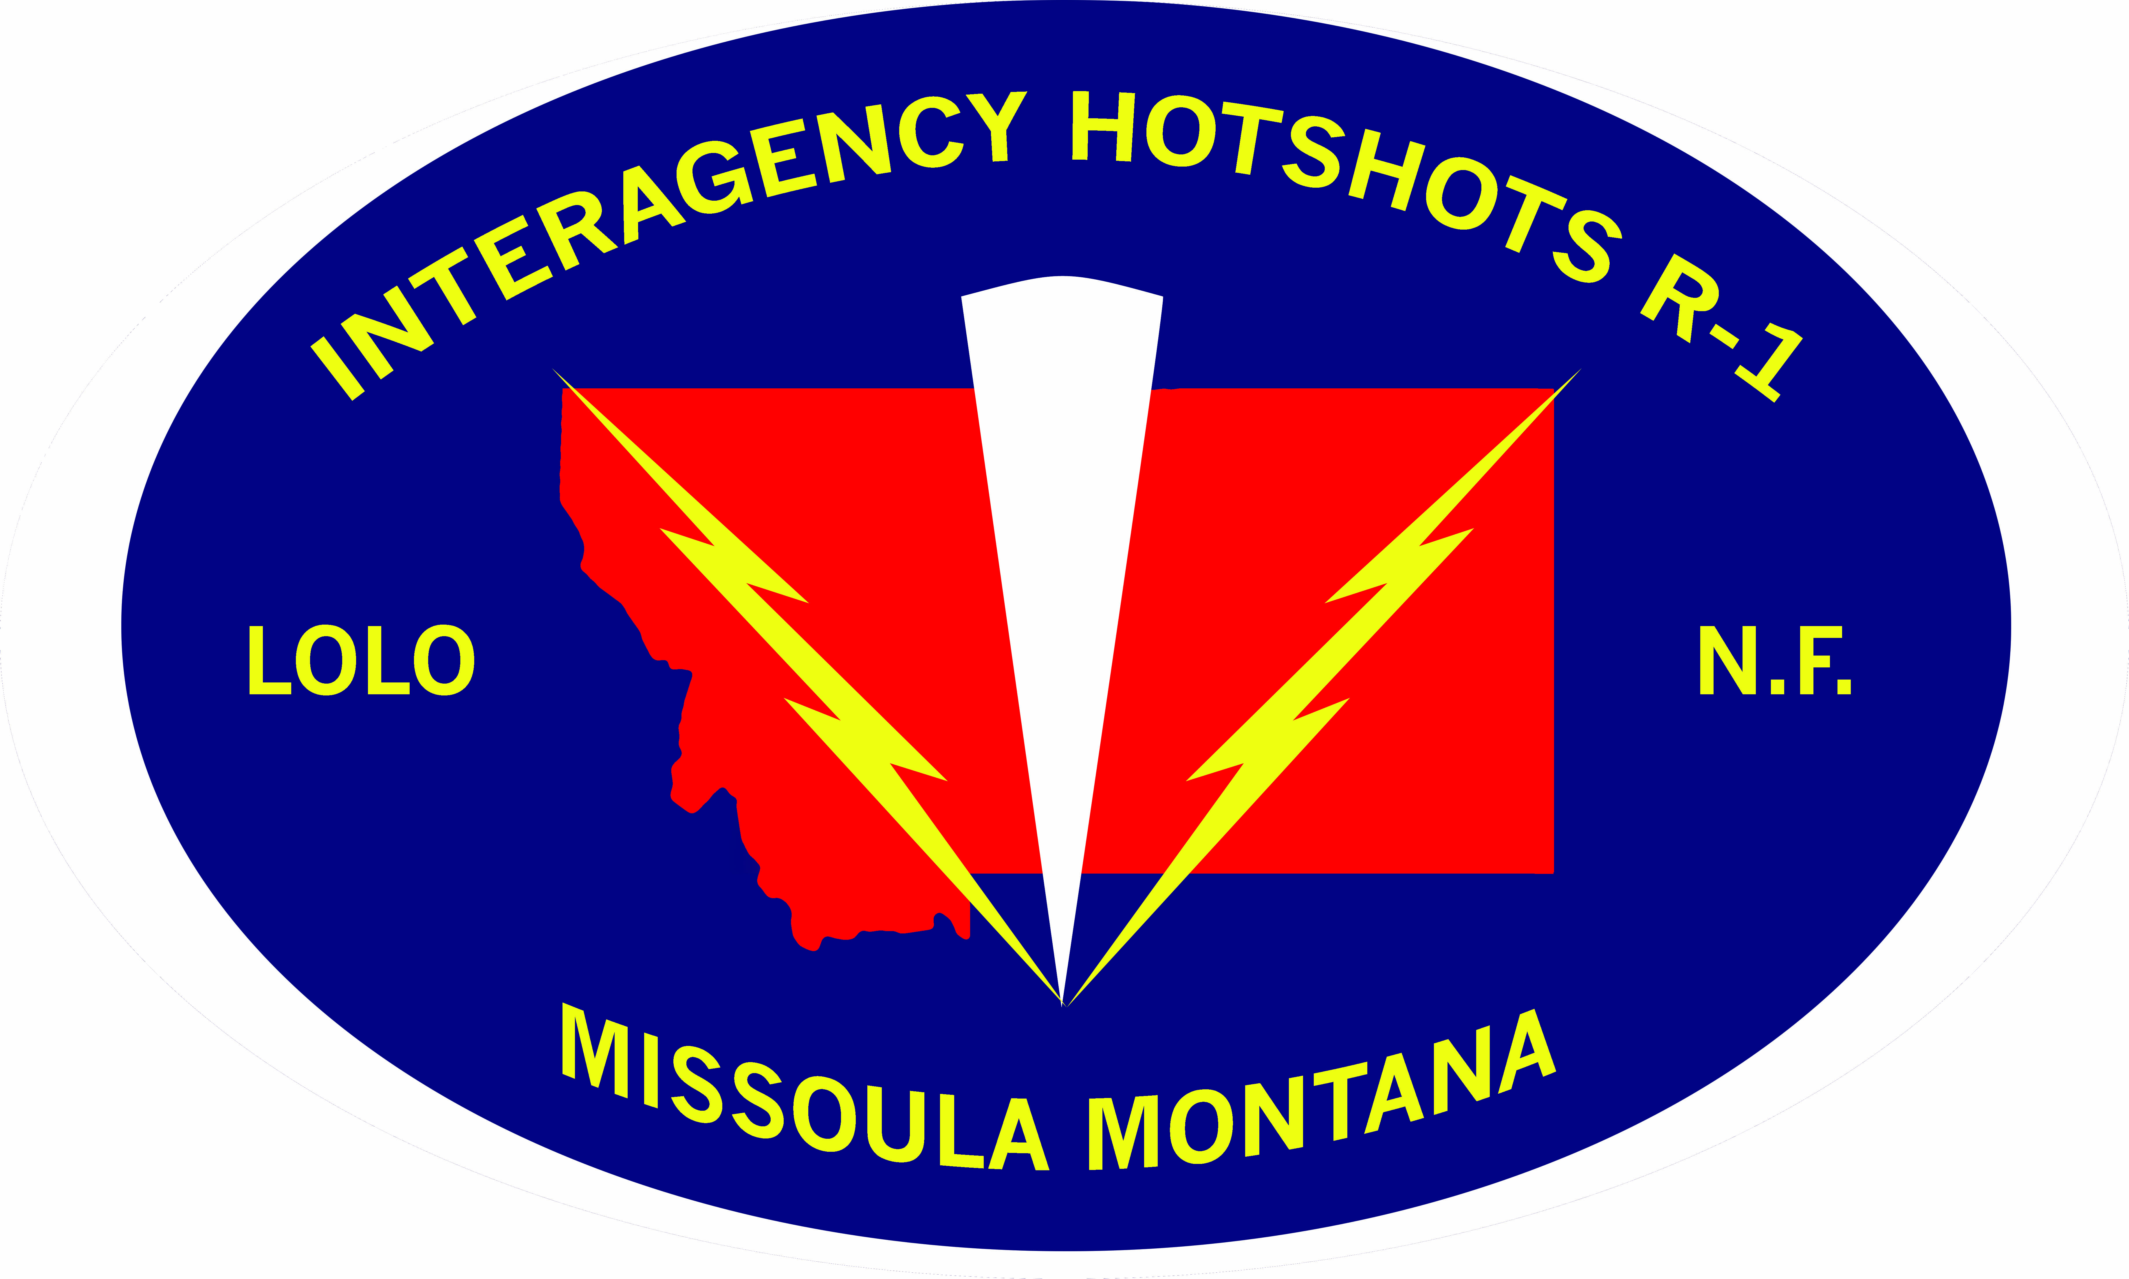

Name:
Email:
Phone:

Wildfire Employment Experience
- Please state specific years employed (e.g. 2019-21)
- If you detailed with an IHC, use the detail block to indicate

Crew (Type):
Location:
Specific Year (s) employed at this duty station:

Aviation (Type):
Location:
Year (s) employed at this duty station:

Engine (Type):
Location:
Year (s) employed at this duty station:

Detail (IHC)
Crew name:
Duration:

Red Card Qualifications:

Chainsaw qualification/experience/seasons at the level:

EMT/State/National Registry/Expiration Date:

Student/Graduation Date/Degree:

Leadership Skills (sports, military, community, etc.)

List 3 traits and how they translate into being a successful member of a hotshot team (Do not use professional, hardworking, motivated, enthusiastic)

What does “everyone owns the unit mission” mean to you?

What separates you from other candidates?

Why do you want to be a hotshot?

List (3) things your current supervisor would say about you?

List 2 references with current contact information (name, email, and phone) and their position title (e.g. Engine Captain, Squad Boss, etc.). One reference must be a supervisor from a wildland fire organization

Fitness test matrix (as described on the website) and date taken…

- Date:
- Max pull-up (3-minutes):
- Max burpee (3-minutes):
- Max plank (5-minutes max):
- Max 20 lb. squats (3-minutes):
- Max push-up (3-minutes):
- 3-mile timed run:

Supplemental items to include:

- Resume (short)
- Do not send master records, NWCG certs, or reference letters unless requested.

